|  |  |
| --- | --- |
| COS 2221 – Practical Assignment 5  GROUP 11 | KabelO Motloung  (22566954)  kAMOGELO mOEKETSE  (22623478)  mONICA bRANCON  (22556771)  vICTOR IGBOJINNA  (22492616)  rETHAKGETSE mANAKA  (22491032) |

General Research and Overview

The flow of the program for our wine tourism will be as follows:

A seamless user flow is required in order to meet the needs of the end-user this will be achieved in our website by first having a landing page basically the home page which will need to allow the user to be able to access all the main page categories on the website. This will be achieved through the use of HTML as if updates need to be made to any HTML element JavaScript DOM (Document Object Manipulation) will be used to further remove or add additional elements. Several HTML pages will need to be created for every distinct page on our wine tourism website such as a wines page, wineries page and a login page. The HTML will just provide the basic visual elements of the screen, but CSS will be used to make the website visually aesthetic to the user to ensure that an interface is created that will be easy for the user to use while still allowing optimal functionality. The functionality behind all these pages will be undertaken by JavaScript which will mostly be used in providing functionality to our website such as searching, sorting and various animations that the user may need to see on the website. The JavaScript will also be used to make calls to our API based on certain functions we may have such as getWine(), getWinePrice(), getWinery(), once either of these functions are called a call will be made to our PHP API. The API is what will be used to contact our database which is basically the middleman between our client and the database it essentially allows the two to communicate with one another. In our database we plan on hosting it on a portable web application called phpMyAdmin this will allow all group members to be able to synchronously access the website and make changes as need through the use SQL which is a querying language used to access and manipulate databases as needed.

To tie all of this together and to ensure that the workflow between group members is seamless and to ensure that we can work on the same program and at the same time and provide updates to the program as milestones are reached, we will use GitHub and Git in order to equally delegate work amongst group members.

References:

MuleSoft (2018). What is an API? (Application Programming Interface). [online] MuleSoft. Available at: https://www.mulesoft.com/resources/api/what-is-an-api.

w3schools (2019). SQL Introduction. [online] W3schools.com. Available at: https://www.w3schools.com/sql/sql_intro.asp.

Web flow. (n.d.). How to create a user flow for your website | Web flow Blog. [online] Available at: https://webflow.com/blog/user-flow-website.

www.javatpoint.com. (n.d.). What is phpMyAdmin: Tutorial, Features, Installation - javatpoint. [online] Available at: https://www.javatpoint.com/phpmyadmin.

**WINE TYPES AND CATEGORIES RESEARCH:**

The six (6) main types of wines:

* Red Wines:

Red wines are produced by fermenting black grapes together with their skins (which imparts the wine's red hue), seeds, and stems. These wines are characterized by their elevated tannin levels, contributing to a slightly astringent and parched sensation experienced on the palate following consumption.

Main* types of red wines:

* Cabernet Sauvignon (regions: Bordeaux, France | Napa Valley, California, USA)
* Merlot (regions: Bordeaux, France | Napa Valley, California, USA| Maipo Valley, Chile | Colchagua Valley and Casablanca Valley)
* Pinot Noir (regions: Germany, Mosel | Oregon, US | Burgundy, France | Marlborough, Wairarapa, Nelson, North Canterbury and Central Otago, New Zealand)
* Zinfandel (regions: Sonoma County/ Napa Valley, California, USA)
* Chianti (regions: Tuscany, Italy)
* Beaujolais (regions: Beaujolais, France)
* Shiraz/Syrah (regions: Barossa Valley, Australia | McLaren Vale, Australia | Hunter Valley, Australia)
* Sangiovese (regions: Tuscany, Italy)
* Malbec (regions: Mendoza, Argentina)
* Nebbiolo (regions: Piedmont, Italy)
* White Wines:

White wines are produced from a combination of white and black grapes. However, unlike red wines that undergo fermentation with grape skins, white wines are processed without the skins. The separation of skins ensures that only the transparent grape juice is utilized. One notable characteristic of white wine is its low tannin content, as its distinctively refreshing, vibrant, and tangy flavours are primarily attributed to its acidic nature.

Types of white wines:

* Chardonnay
* Sauvignon Blanc (region: Marlborough, New Zealand | Loire Valley, France |California, USA)
* Pinot Grigio
* Gewürztraminer (region: Alsace, France | Germany | New Zealand)
* Riesling (region: Germany | Alsace, France | Finger Lakes, New York, USA)
* Chenin Blanc
* Rosé Wines:

Rosé wine is recognized for its delicate blush or pink hue. This charming colour is achieved through a brief fermentation process where the juice of black grapes is allowed to ferment with its’ skins for a short period of time, imparting the desired pigmentation. It is important to note that, like white wine, rosé possesses low tannin levels, although there are some rosés are dry. (Gould, 2021) With its pleasant and refreshing taste, rosé has garnered popularity among a wide range of individuals, it is ideal for summer gatherings as it serves as an excellent option for an introductory wine due to its light and subtly sweet flavour profile.

Types of rosé wines:

* Provence Rosé
* Grenache Rosé (origin: Spain)
* Sangiovese Rosé (origin: Italy)
* Sparkling Wines:

Sparkling wines are carbonated wines colloquially referred to as "bubbly". (Jordan, 2019) A blend of black and white grapes, with carbon dioxide naturally arising as a result of the fermentation process are used to make sparkling wine. (Virgin Wine Online, 2021) Among the various sparkling wines, champagne holds a prominent position, often associated with festive occasions such as New Year's celebrations and weddings.

Types of sparkling wines:

* Champagne (region: France in Montagne de Reims/ Côte des Blancs/ Côte de Sézanne/ Vallée de la Marne and Aube)
* Cava (region: Spain in Catalunya/Rioja)
* Prosecco (region: Italy in Veneto/Friuli-Venezia Giulia)
* Asti Spumante (region: Italy in Piedmont)
* Crémant (region: France in Loire)
* English Sparkling Wine (region: England in Sussex/Kent/Hampshire/Surrey)
* Dessert Wines:

Dessert wines are very sweet wines that are drunk after a meal with (and sometimes as) dessert. This type of wine can be produced in various styles, including late harvest wines (grapes left on the vine longer for higher sugar content), ice wines (made from grapes frozen on the vine), and botrytized wines (made from grapes affected by noble rot). Dessert wines include any sweet wine which is why some fortified wines are a category of desert wines too.

Types of dessert wines:

* Moscato (region: )
* Sherry (region: )
* Port (region: )
* Sauternes (region: )
* Ice Wine (region: )
* Fortified Wines:

Fortified wines are wines that contain spirits such as brandy which are added in during the fermentation process. This type of wine has a higher alcohol content than any other type of wine.

Types of fortified wines:

* Port
* Sherry
* Madeira
* Marsala (region: Marsala in Sicily, Italy)

**Wine Website Research**

**Website Design Ideas**

The design of our website/web-application will be inspired from a couple of different websites. In our website to list the different types of wines offered through the website. We would like to implement a slider similar to the one in the picture below. This design can be found at https://www.getwine.co.za/.

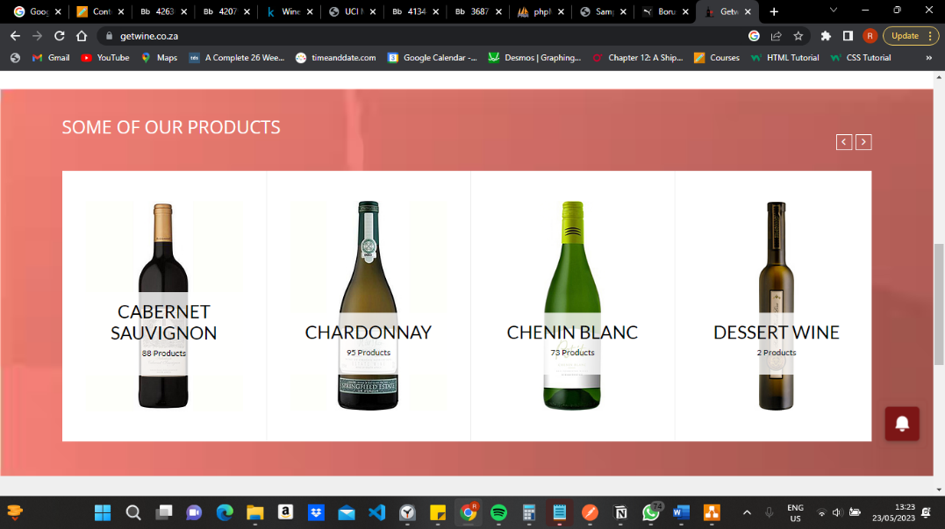

**Management of Users**

To manage the users and the logging in of users. We will have a page that will be used for logging in or signing up. The design inspiration of this page will be taken from the login and sign up page found at the page below <https://www.winecellar.co.za/customer/account/login/referer/aHR0cHM6Ly93d3cud2luZWNlbGxhci5jby56YS8%2C/>

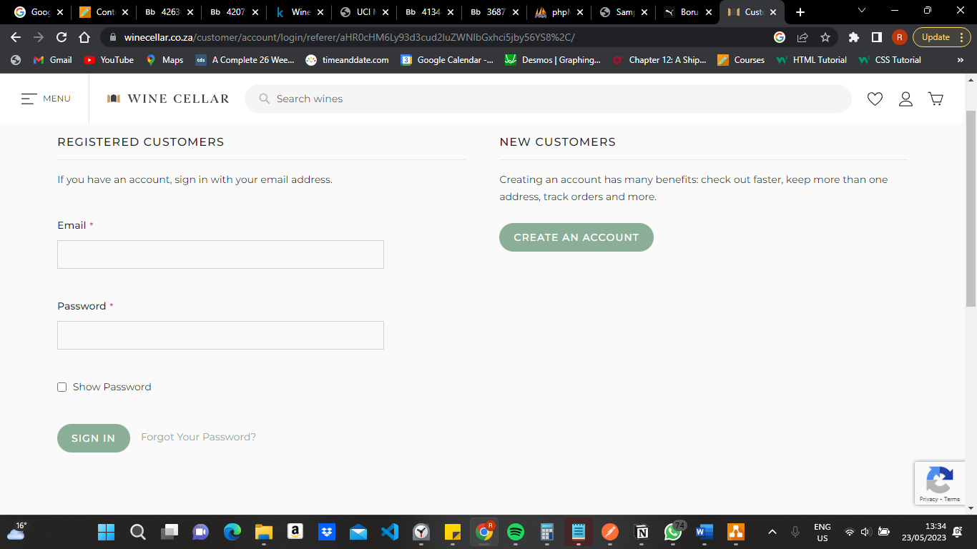

**Management of Verified Wineries**

To manage verified wineries, we will have a column in our Winery entity which stores a validated value. We will then use this value to query all the verified wineries and display them on our website.

**Sorting application**

To implement our sorting, we will have a sorting dropdown menu and based the sorting the user of the website selects functions in the backend will be executed in order to only show the wines according to the sorting option the user selected. An inspiration our design will take from is of the page below. The page is found at: https://www.winefolk.co.za/shop/?orderby=price

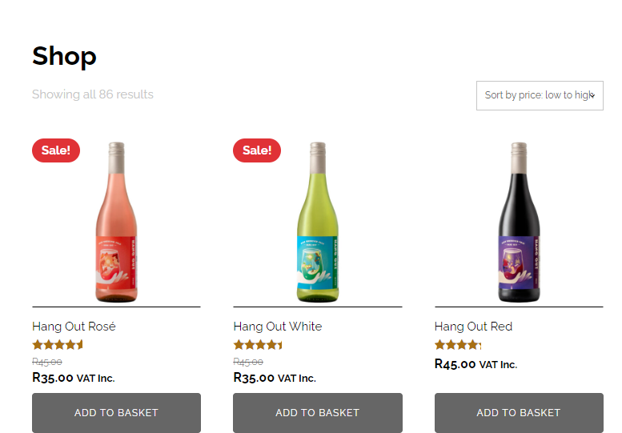

**Management of wine and winery information**

To manage the addition and removal of the wines. There will be specific users with privileges that allow them to add, remove and update wines that are listed on the website. This user will also be allowed to update, remove, and add information about wineries. These privileged users will be able to update any information on the wineries such as the wineries website, location, and address.

**Suggestion of the best destination based on location.**

To suggest the best destination based on location we will ask the user which region they reside in. Based on the user’s response will execute a query which lists the best wineries in the region that they can visit. This will be displayed as a list on our website. Our list will be similar to the page below. Found at https://winefolly.com/lifestyle/wine-folly-names-top-wine-destinations-for-2022/

Add primary key Users:

CREATE TABLE `u22492616_COS221`. ( `UserID` VARCHAR(10) NOT NULL , `Name` VARCHAR(100) NOT NULL , `Email` VARCHAR(50) NOT NULL , `Age` INT NOT NULL , `National_ID` VARCHAR(13) NOT NULL ) ENGINE = InnoDB;

ALTER TABLE `User` ADD PRIMARY KEY( `UserID`);

ALTER TABLE `User` ADD UNIQUE(`National_ID`);

insert user:

INSERT INTO `User`(`UserID`, `Name`, `Email`, `Age`, `National_ID`)

VALUES ('us1923', 'John Smith', 'johnsmith@example.com', 25, '8801235065084'),

('us7529', 'Emma Johnson', 'emma.johnson@example.com', 28, '9204124050082'),

('us5364', 'Michael Anderson', 'michael.anderson@example.com', 33, '8805236123083'),

('us9928', 'Sophia Williams', 'sophia.williams@example.com', 21, '0110144037087'),

('us6835', 'Jacob Brown', 'jacob.brown@example.com', 19, '0101245185087'),

('us8291', 'Olivia Davis', 'olivia.davis@example.com', 22, '9708165067089'),

('us4762', 'Liam Wilson', 'liam.wilson@example.com', 32, '8804286136087'),

('us6527', 'Ava Taylor', 'ava.taylor@example.com', 20, '0205124321087'),

('us4198', 'Noah Miller', 'noah.miller@example.com', 23, '9905235031085'),

('us8794', 'Isabella Martinez', 'isabella.martinez@example.com', 27, '9508174120083'),

('us2671', 'James Johnson', 'james.johnson@example.com', 29, '9306255124084'),

('us1446', 'Charlotte Anderson', 'charlotte.anderson@example.com', 26, '9403314136086'),

('us5579', 'Benjamin Wilson', 'benjamin.wilson@example.com', 31, '9106056095085'),

('us7203', 'Mia Davis', 'mia.davis@example.com', 30, '9102114071085'),

('us4839', 'Lucas Taylor', 'lucas.taylor@example.com', 24, '9712055148084'),

('us6192', 'Amelia Jones', 'amelia.jones@example.com', 20, '0212194030080'),

('us2750', 'Ethan Martinez', 'ethan.martinez@example.com', 19, '0310045085082'),

('us8827', 'Harper Moore', 'harper.moore@example.com', 21, '0212284071085'),

('us5313', 'Alexander Jackson', 'alexander.jackson@example.com', 22, '0110025166084'),

('us7618', 'Sofia Thomas', 'sofia.thomas@example.com', 25, '9609234056083'),

('us1245', 'William Brown', 'william.brown@example.com', 30, '9107025122085'),

('us6582', 'Emily Wilson', 'emily.wilson@example.com', 24, '9706024137084'),

('us3487', 'Henry Davis', 'henry.davis@example.com', 19, '0404075062085'),

('us7294', 'Samantha Johnson', 'samantha.johnson@example.com', 28, '9307044048084'),

('us4639', 'Daniel Smith', 'daniel.smith@example.com', 26, '9512065006084'),

('us6218', 'Avery Anderson', 'avery.anderson@example.com', 23, '9908275078087'),

('us8973', 'Sophie Taylor', 'sophie.taylor@example.com', 20, '0202284244083'),

('us1654', 'Joseph Miller', 'joseph.miller@example.com', 31, '9105046035085'),

('us7321', 'Grace Martinez', 'grace.martinez@example.com', 22, '0110104120088'),

('us4287', 'Samuel Jones', 'samuel.jones@example.com', 27, '9404175125085'),

('us2718', 'Evelyn Moore', 'evelyn.moore@example.com', 21, '0210174243085'),

('us5096', 'Alexander Davis', 'alexander.davis@example.com', 29, '9308216105084'),

('us7403', 'Abigail Wilson', 'abigail.wilson@example.com', 25, '9705124198086'),

('us8491', 'David Anderson', 'david.anderson@example.com', 33, '8905136089082'),

('us3847', 'Victoria Johnson', 'victoria.johnson@example.com', 32, '8808174044087'),

('us6723', 'Christopher Taylor', 'christopher.taylor@example.com', 20, '0211204231085'),

('us5982', 'Elizabeth Martinez', 'elizabeth.martinez@example.com', 23, '9909134159082'),

('us1937', 'Andrew Brown', 'andrew.brown@example.com', 26, '9511045181083'),

('us8562', 'Scarlett Davis', 'scarlett.davis@example.com', 27, '9407054141086'),

('us4631', 'Grace Thomas', 'grace.thomas@example.com', 24, '9710144092086')

alter table:

ALTER TABLE `User` ADD `Password` VARCHAR(50) NOT NULL AFTER `National_ID`;

ALTER TABLE `User` ADD `Surname` VARCHAR(50) NOT NULL AFTER `Name`;

Create Wine club membership:

CREATE TABLE `u22492616_COS221`.`Wine_Club_Membership` ( `National_ID` VARCHAR(13) NOT NULL , `Club Name` VARCHAR(30) NOT NULL ) ENGINE = InnoDB;

ALTER TABLE `Wine_Club_Membership` ADD PRIMARY KEY( `National_ID`, `Club Name`);

insert:

INSERT INTO `Wine_Club_Membership`(`National_ID`, `Club Name`)

VALUES ('9107025122085', 'Prestige Vintage Society'),

('9710144092086', 'Noble Estate Wine Club'),

('9908275078087','Grand Cru Connoisseurs'),

('8804286136087','Opulent Cellar Selections'),

('8804286136087', 'Grand Cru Connoisseurs'),

('0110104120088','Luxe Reserve Wine Collective'),

('0110104120088', 'Noble Estate Wine Club'),

('9706024137084', 'The Reserve Vine Society'),

('9204124050082', 'Opulent Cellar Selections'),

('0202284244083', 'Prestige Vintage Society')

create connoisseur:

CREATE TABLE `u22492616_COS221`.`Connoisseur` ( `UserID` VARCHAR(10) NOT NULL , `CertificateID` VARCHAR(10) NOT NULL ) ENGINE = InnoDB;

ALTER TABLE `Connoisseur` ADD PRIMARY KEY( `UserID`);

INSERT INTO `Connoisseur`(`UserID`, `CertificateID`)

VALUES ('us1923', 'ts56342'),

('us7529', 'ts90857'),

('us5364', 'ts28751'),

('us9928', 'ts17643'),

('us6835', 'ts64529'),

('us8291', 'ts48273'),

('us4762', 'ts90764'),

('us6527', 'ts31597'),

('us4198', 'ts76413'),

('us8794', 'ts62581'),

('us2671', 'ts83962'),

('us1446', 'ts54023'),

('us5579', 'ts94678'),

('us7203', 'ts12857'),

('us4839', 'ts34769'),

('us6192', 'ts71286'),

('us2750', 'ts63512'),

('us8827', 'ts48026'),

('us5313', 'ts90173'),

('us7618', 'ts26789')

create Reviews:

CREATE TABLE `u22492616_COS221`.`Reviews` ( `Comment` VARCHAR(200) NOT NULL , `Rating` INT NOT NULL , `WineID` VARCHAR(50) NOT NULL , `userID` VARCHAR(10) NOT NULL ) ENGINE = InnoDB;

ALTER TABLE `Reviews` ADD PRIMARY KEY( `WineID`, `userID`);

INSERT INTO `Reviews`(`Comment`, `Rating`, `WineID`, `userID`)

VALUES ("This wine is absolutely fantastic!", 9, 'W001', 'us8794'),

("An exquisite blend with rich flavors.", 8, 'W001', 'us1937'),

("Smooth and elegant, a true delight.", 9, 'W001', 'us4839'),

("A heavenly wine that leaves a lasting impression.", 10, 'W002', 'us1937'),

("This wine exceeded my expectations!", 8, 'W001', 'us1245'),

("Deliciously complex with a velvety finish.", 9, 'W003', 'us7203'),

("An exceptional wine that captivates the senses.", 10, 'W003', 'us2750'),

("Rich and bold, an absolute masterpiece.", 9, 'W004', 'us8291'),

("A beautifully balanced wine with remarkable depth.", 9, 'W004', 'us7618'),

("Incredibly smooth with a lingering finish.", 8, 'W005', 'us5579'),

("An extraordinary wine that leaves you wanting more.", 10, 'W002', 'us1245'),

("This wine is pure elegance in a bottle.", 9, 'W006', 'us5928'),

("A truly exceptional vintage worth savoring.", 9, 'W007', 'us1446'),

("One word: perfection!", 10, 'W002', 'us8562'),

("A delightful wine with layers of complexity.", 8, 'W008', 'us5313'),

("Exquisite flavors that dance on the palate.", 9, 'W009', 'us1654'),

("This wine is a work of art.", 9, 'W010', 'us5096'),

("A wine that demands attention and admiration.", 9, 'W011', 'us2671'),

("Velvety smooth with a lingering finish.", 8, 'W011', 'us6192'),

("A true masterpiece of winemaking.", 10, 'W011', 'us8562'),

("Rich and full-bodied with impeccable balance.", 9, 'W012', 'us1937'),

("This wine is a true gem!", 9, 'W009', 'us6582'),

("Elegant and refined, a wine for special occasions.", 8, 'W010', 'us7283'),

("A wine that showcases the artistry of the winemaker.", 9, 'W005', 'us7203'),

("This wine is simply extraordinary!", 10, 'W004', 'us5313'),

("Full of depth and complexity, a true treasure.", 9, 'W006', 'us1245'),

("An outstanding wine that leaves a lasting impression.", 9, 'W008', 'us8562'),

("Silky smooth with a long, lingering finish.", 8, 'W002', 'us4839'),

("A wine that exemplifies elegance and sophistication.", 9, 'W007', 'us1654'),

("This wine is a revelation!", 10, 'W012', 'us5096')

Create admin_user table

CREATE TABLE `u22492616_COS221`.`Admin_User` ( `AdminID` VARCHAR(20) NOT NULL , `Name` VARCHAR(50) NOT NULL , `Surname` VARCHAR(50) NOT NULL , `Password` VARCHAR(30) NOT NULL ) ENGINE = InnoDB;

ALTER TABLE `Admin_User` ADD PRIMARY KEY( `AdminID`);

ALTER TABLE `Admin_User` ADD `Email` VARCHAR(50) NOT NULL AFTER `Surname`;

Grape Varietal Insert Queries

INSERT INTO `Grape_Varietal` (`Varietal_ID`, `Name`, `Wine_Type`, `Description`) VALUES ('GV001', 'Cabernet Sauvignon', 'Red', 'A renowned red wine grape known for producing full-bodied wines with blackcurrant and dark fruit flavors, firm tannins, and aging potential.\r\nMerlot: A versatile red grape variety, often producing wines with softer tannins, medium body, and flavors of blackberry, plum, and chocolate.\r\n'), ('GV002', 'Pinot Noir:', 'Red', 'A delicate and expressive red grape variety associated with wines that exhibit nuanced flavors of red berries, cherry, earthiness, and silky tannins.\r\n');

INSERT INTO `Grape_Varietal` (`Varietal_ID`, `Name`, `Wine_Type`, `Description`) VALUES ('GV003', 'Shiraz', 'Red', ' A dark-skinned grape known for its bold and robust wines, showcasing dark fruit flavors, spice, and often a hint of black pepper.'), ('GV004', 'Sangiovese', 'Red', 'The primary grape of Tuscany, Italy, producing wines with medium body, high acidity, and flavors of cherry, plum, and herbal notes.'), ('GV005', 'Chardonnay', 'White', 'A versatile white grape known for its wide range of styles, producing wines that can be unoaked or oaked, with flavors ranging from citrus and apple to tropical fruits and buttery notes.'), ('GV006', 'Sauvignon Blanc', 'White', 'A refreshing white grape variety offering vibrant acidity, herbal and grassy aromas, and flavors of citrus, tropical fruits, and sometimes a hint of minerality.'), ('GV007', 'Riesling', 'White', 'A highly aromatic white grape variety known for its wide range of sweetness levels, producing wines with floral aromas, flavors of stone fruits, and a characteristic mineral undertone.'), ('GV008', 'Pinot Grigio', 'White', 'A white grape variety producing crisp and refreshing wines with flavors of citrus, pear, and sometimes a hint of spice.'), ('GV009', 'Gewürztraminer', 'White', 'An aromatic white grape variety associated with wines that offer intense floral aromas, lychee and tropical fruit flavors, and a slightly spicy character.'), ('GV010', 'Malbec', 'Red', 'Originally from France, Malbec produces wines with deep color, rich black fruit flavors, and velvety tannins, and is often associated with Argentine wines.'), ('GV011', 'Viognier', 'White', 'A full-bodied white grape variety known for its aromatic profile, with notes of apricot, peach, tropical fruits, and sometimes a hint of floral and spice.'), ('GV012', 'Grenache', 'Rosé', 'A red grape variety that is often used to produce rosé wines, offering flavors of red berries, citrus, and sometimes a touch of spice.'), ('GV013', 'Cinsault', 'Rosé', 'Another red grape variety frequently used in rosé production, contributing to wines with delicate red fruit flavors and a light, refreshing character.'), ('GV014', 'Mourvèdre', 'Rosé ', 'A red grape known for producing deeply colored rosé wines, offering flavors of ripe berries, watermelon, and a hint of spice.'), ('GV015', 'Chardonnay', 'Sparkling', 'Often used as a primary grape in sparkling wine production, contributing to the wine\'s structure, acidity, and flavors.'), ('GV016', 'Pinot Noir', 'Sparkling', 'Another key grape in the production of sparkling wines, providing body, red fruit flavors, and contributing to the wine\'s aging potential.'), ('GV017', 'Pinot Meunier', 'Sparkling', 'A grape variety commonly used in Champagne production, often adding fruitiness and floral notes to the sparkling wine.'), ('GV018', 'Riesling', 'Dessert', 'Known for producing sweet dessert wines with flavors of honey, apricot, and tropical fruits, balancing acidity.'), ('GV019', 'Nebbiolo', 'Red', 'Nebbiolo is a noble Italian grape variety known for producing full-bodied, complex wines with high tannins, high acidity, and flavors of red fruits, roses, tar, and earthy undertones. It is often associated with age-worthy wines that require extended cellaring to fully develop their character.'), ('GV020', 'Gamay', 'Red', 'Gamay produces light-to-medium-bodied red wines with bright acidity and vibrant fruit flavors of red berries, such as raspberry and strawberry. Beaujolais wines are known for their freshness, soft tannins, and sometimes exhibit unique fruity characteristics like bubblegum or banana notes.'), ('GV021', 'Sangiovese', 'Red', 'Sangiovese is a versatile grape that produces medium-bodied wines with moderate acidity, firm tannins, and flavours of cherry, plum, and herbal notes. Chianti wines often display a characteristic Tuscan terroir, offering a balance between fruitiness, earthiness, and a touch of spice.'), ('GV022', 'Zinfandel', 'Red', 'Zinfandel can produce a range of styles, from medium to full-bodied red wines with rich, ripe fruit flavours of blackberry, raspberry, and sometimes a hint of spice. It often exhibits bold characteristics, high alcohol content, and supple tannins.'), ('GV023', 'Chenin Blanc', 'White', 'Chenin Blanc produces wines with a wide range of styles, from dry to sweet. Dry Chenin Blanc offers crisp acidity, floral aromas, and flavours of green apple, pear, and honeyed notes. Sweet Chenin Blanc wines exhibit honeyed sweetness, ripe fruit flavours, and can have aging potential.'), ('GV024', 'Provence ', 'Rosé', 'Grenache contributes red fruit flavours, Cinsault adds delicate red berry notes, and Mourvèdre brings depth and spice to Provence rosé wines. These wines are known for their pale colour, crisp acidity, and refreshing flavours of strawberry, watermelon, and herbs.'), ('GV025', 'Sangiovese', 'Rosé', 'Sangiovese rosé wines exhibit flavours of red berries, citrus, and sometimes a hint of spice. They offer a balance between fruity and floral characteristics, along with vibrant acidity and a medium-bodied structure.'), ('GV026', 'Sauternes', 'Dessert', 'Sauternes is a renowned French sweet wine made from grapes affected by noble rot (Botrytis cinerea). It showcases luscious flavors of honey, apricot, marmalade, and a balancing acidity.'), ('GV027', 'Tokaji', 'Dessert', 'Tokaji wines originate from Hungary and are known for their sweet, botrytized character. They exhibit flavors of dried fruits, honey, orange peel, and a complex, rich profile.'), ('GV028', 'Pedro Ximénez', 'Dessert', 'Primarily grown in Spain, Pedro Ximénez is a white grape used to produce intensely sweet and viscous dessert wines. These wines offer flavors of raisins, figs, toffee, and molasses.'), ('GV029', 'Muscat', 'Dessert', 'Muscat is a family of grapes that includes various sub-varieties such as Muscat Blanc à Petits Grains and Muscat of Alexandria. Muscat-based dessert wines are aromatic, often featuring notes of orange blossom, apricot, grape, and a hint of sweetness.'), ('GV030', 'Icewine', 'Dessert', 'Icewine is produced from grapes left to freeze on the vine, concentrating their sugars and flavors. It offers a unique balance of intense sweetness, acidity, and flavors of tropical fruits, honey, and candied citrus.');

CREATE RED WINES

CREATE TABLE `u22492616_COS221`.`Red_Wine` ( `ID` INT NOT NULL AUTO_INCREMENT , `WineID` VARCHAR(10) NOT NULL , `Tannin` TINYINT NOT NULL , PRIMARY KEY (`ID`)) ENGINE = InnoDB;

INSERT INTO `Red_Wine` (`ID`, `WineID`, `Tannin`) VALUES (NULL, 'W001', '4'), (NULL, 'W002', '5'), (NULL, 'W003', '3')

CREATE WHITE WINES

CREATE TABLE `u22492616_COS221`.`White_Wine` ( `ID` INT NOT NULL AUTO_INCREMENT , `WineID` VARCHAR(10) NOT NULL , `Shade` VARCHAR(20) NOT NULL , PRIMARY KEY (`ID`)) ENGINE = InnoDB;

INSERT INTO `White_Wine` (`ID`, `WineID`, `Shade`) VALUES (NULL, 'W004', 'Pale Yellow'), (NULL, 'W005', 'Pale Straw'), (NULL, 'W006', 'Pale Straw')

CREATE ROSE

CREATE TABLE `u22492616_COS221`.`Rosé_Wine` ( `ID` INT NOT NULL AUTO_INCREMENT , `WineID` VARCHAR(10) NOT NULL , `Percentage_Red` TINYINT NOT NULL , `Percentage_White` TINYINT NOT NULL , PRIMARY KEY (`ID`)) ENGINE = InnoDB;

INSERT INTO `Rosé_Wine` (`ID`, `WineID`, `Percentage_Red`, `Percentage_White`) VALUES (NULL, 'W007', '60', '40'), (NULL, 'W008', '73', '27'), (NULL, 'W009', '64', '36')

SPARKLING

CREATE TABLE `u22492616_COS221`.`Sparkling_Wine` ( `ID` INT NOT NULL AUTO_INCREMENT , `WineID` VARCHAR(10) NOT NULL , `Carbon_Content` VARCHAR(20) NOT NULL , PRIMARY KEY (`ID`)) ENGINE = InnoDB;

INSERT INTO `Sparkling_Wine` (`ID`, `WineID`, `Carbon_Content`) VALUES (NULL, 'W010', 'medium'), (NULL, 'W011', 'medium'), (NULL, 'W012', 'medium')

DESSERT

CREATE TABLE `u22492616_COS221`.`Dessert_Wine` ( `ID` INT NOT NULL AUTO_INCREMENT , `WineID` VARCHAR(10) NOT NULL , `Style` VARCHAR(20) NOT NULL , PRIMARY KEY (`ID`)) ENGINE = InnoDB

INSERT INTO `Dessert_Wine` (`ID`, `WineID`, `Style`) VALUES (NULL, 'W013', 'Sweet, Fruity'), (NULL, 'W014', 'Sweet, barrel-aged')

WINES

CREATE TABLE `u22492616_COS221`. ( `WineID` VARCHAR(10) NOT NULL , `WIneryID` VARCHAR(10) NOT NULL , `Name` VARCHAR(100) NOT NULL , `Price(ZAR)` DOUBLE NOT NULL , `Bottle_Size(ml)` SMALLINT NOT NULL , `VarietalID` VARCHAR(10) NOT NULL , PRIMARY KEY (`WineID`)) ENGINE = InnoDB;

INSERT INTO `Wine` (`WineID`, `WIneryID`, `Name`, `Price(ZAR)`, `Bottle_Size(ml)`, `VarietalID`) VALUES ('W001', '3', 'Vilafonté, Series C 2014', '2575.00', '750', 'GV007'), ('W002', '4', 'Velvet Noir', '479.95', '750', 'GV010'), ('W003', '7', 'Velvet Noir', '767.91', '750', 'GV008'), ('W004', '4', 'Groot Constantia - Sauvignon Blanc, Constantia - 2021', '518.34', '750', 'GV009'), ('W005', '2', 'Groot Constantia Gouverneurs Reserve White 2021', '902.30', '750', 'GV023'), ('W006', '1', 'Louis Latour Corton-Charlemagne 2019', '3495.00', '750', 'GV013'), ('W007', '10', 'Groot Constantia Rosé 2022', '1605.00', '750', 'GV027'), ('W008', '4', 'Rosé Elegance', '345.56', '750', 'GV008'), ('W009', '14', 'Pink Blossom', '479.95', '750', 'GV022'), ('W010', '9', 'Sparkling Rosé Royale', '671.92', '750', 'GV005'), ('W011', '6', 'Bubbly Blanc de Blancs', '863.90', '750', 'GV0018'), ('W012', '6', 'Pranaah Effervescence Elegance', '825.51', '750', 'GV0019'), ('W013', '9', 'Rijk\'s 888 Pinotage Gold 2015', '1650.00', '750', 'GV027'), ('W014', '8', 'Groot Constantia Cape Ruby 2018', '989.99', '750', 'GV028')

QUALITY

CREATE TABLE `u22492616_COS221`.`Quality` ( `WineID` VARCHAR(10) NOT NULL , `Alcohol_Content(%)` FLOAT NOT NULL , `Density(g/ml)` FLOAT NOT NULL , `Residual Sugar(g/l)` FLOAT NOT NULL , `Fixed_Acidity(g/l)` FLOAT NOT NULL , `pH` FLOAT NOT NULL ) ENGINE = InnoDB;

INSERT INTO `Quality` (`WineID`, `Alcohol_Content(%)`, `Density(g/ml)`, `Residual Sugar(g/l)`, `Fixed_Acidity(g/l)`, `pH`) VALUES ('W001', '14.5', '0.992', '2', '6.5', '3.6'), ('W002', '13.5', '0.995', '4', '5.8', '3.5'), ('W003', '13.8', '0.990', '1.5', '6.2', '3.4'), ('W004', '13.14', '0.992', '1.5', '6', '3.34')

INSERT INTO `Quality` (`WineID`, `Alcohol_Content`, `Density`, `Residual Sugar`, `Fixed_Acidity`, `pH`) VALUES ('W006', '12.22', '0.784', '2.7', '5', '3.30'), ('W007', '12.67', '0.455', '1.1', '5.6', '3.36'), ('W008', '12.5', '0.991', '4', '6', '3.3'), ('W009', '13.5', '0.992', '5', '6.8', '3.5'), ('W010', '11.5', '0.992', '10', '7', '3.3'), ('W011', '13', '0993', '6', '6.8', '3.1'), ('W012', '11.5', '0.990', '12', '6.2', '3.3'), ('W013', '15.43', '1.075', '2.8', '6.1', '3.66'), ('W014', '18.11', '1.025', '105.4', '5.4', '3.62');